HYDERABAD INSTITUTE FOR TECHNOLOGY
AND MANAGEMENT SCIENCES
Algorithm Design & Analysis

Project Report
Text Similarity Checker Using Longest Common Subsequence

Course | Algorithm Design & Analysis
Institution | Hyderabad Institute for Technology and Management Sciences
Problem | Text Similarity Checker (Plagiarism Detection)
Algorithm | Longest Common Subsequence — Dynamic Programming
Date | 10 May 2026
Submitted By | Zainab Rehan (24BSSW037)  Khizar Ghouri (24BSSW015)

1. Abstract
Plagiarism detection is a critical concern in academic institutions. This report presents a Text Similarity Checker designed to compare two student assignment documents and compute their degree of textual similarity. The system identifies the Longest Common Subsequence (LCS) between the two texts using a classic Dynamic Programming (DP) approach, highlights matching tokens in both documents, and calculates a normalized similarity percentage using the Dice coefficient formula. The solution handles both character-level and word-level comparison modes, supports direct text input as well as .txt file uploads, and presents results through an interactive web-based interface. The DP algorithm guarantees an optimal O(m×n) solution, making it well-suited for practical document lengths encountered in educational settings.

2. Problem Description & Modeling

2.1 Real-World Problem
Academic plagiarism — where students copy or lightly paraphrase another person's work — is a widespread challenge in universities and schools. Instructors require automated tools to quickly flag suspicious submissions without reading every document manually. A practical plagiarism checker must:
- Detect copied text even when minor words are added or removed between copied phrases.
- Tolerate light paraphrasing such as synonym substitution or sentence reordering.
- Provide a clear, quantifiable similarity score to guide human judgment.
- Highlight exactly which parts of both documents are common.

The objective of this solution is to build a tool that takes two text documents as input, computes their structural overlap using the LCS algorithm, and presents a similarity percentage together with a visual breakdown of matched and unmatched content.

2.2 Computational Model
The problem is formalized with the following inputs, outputs, and constraints:

Category | Item | Description
Input | Document A | First text string / uploaded .txt file
Input | Document B | Second text string / uploaded .txt file
Input | Mode | Character-level or Word-level tokenization
Output | LCS Sequence | The longest common subsequence of tokens
Output | Similarity % | Dice coefficient: 2×|LCS| / (|A|+|B|) × 100
Output | Highlighted Text | Matched tokens highlighted in both documents
Output | DP Matrix | Full (m+1)×(n+1) table with backtrack path
Constraint | Input length | Practical limit: ~5,000 tokens per document
Constraint | File type | Plain text (.txt) only for file upload

Key Constraints & Assumptions
- Both documents are treated as plain text sequences (no formatting metadata).
- Comparison is case-sensitive by default (future versions may add case-insensitive mode).
- The LCS is a subsequence, not a substring — gaps between matched tokens are allowed.
- Similarity is measured using the symmetric Dice coefficient, not simple ratio.

3. Mapping to Known Problem

3.1 Identified Known Problem
The Text Similarity Checker maps directly to the Longest Common Subsequence (LCS) problem, one of the most studied problems in combinatorics and algorithm design. Given two sequences A and B of length m and n respectively, LCS finds the longest sequence that appears in both A and B in the same relative order (but not necessarily contiguously).

3.2 Justification
The LCS mapping is appropriate for the following reasons:
- Order preservation: Plagiarists typically preserve the order of copied sentences even when inserting or deleting words. LCS captures this.
- Insertion/deletion tolerance: Unlike exact substring matching, LCS does not require the common portion to be contiguous, making it robust to minor edits.
- Quantifiability: The LCS length directly feeds a normalized similarity score (Dice coefficient), providing a meaningful metric for grading similarity.
- Proven optimality: The DP formulation guarantees the globally longest common subsequence, not a local approximation.

3.3 Alternative Approaches Considered
The following alternatives were evaluated before selecting LCS:

Approach | Strength | Weakness
Exact Substring (KMP) | O(m+n) very fast | Fails when any word is inserted between copied phrases
Bag-of-Words Overlap | Simple to implement | Ignores order; heavily over-reports similarity
Edit Distance (Levenshtein) | Captures all edit types | Does not directly highlight common parts; heavier computation
LCS (Selected) | Order-preserving, gap-tolerant, optimal | O(m×n) space — not ideal for very large documents

4. Algorithm Design

4.1 Step-by-Step Strategy / Pseudocode
The algorithm follows five clearly defined stages:

- Tokenize: Split each document into a sequence of tokens (characters or words depending on mode). This produces arrays A[0..m-1] and B[0..n-1).
- Initialize DP Table: Create a 2D integer array dp of size (m+1)×(n+1), initialized to 0. dp[i][j] will store the LCS length for the first i tokens of A and first j tokens of B.
- Fill Recurrence Relation: Iterate i from 1 to m and j from 1 to n. If A[i-1] equals B[j-1], set dp[i][j] = dp[i-1][j-1]+1. Otherwise, set dp[i][j] = max(dp[i-1][j], dp[i][j-1]).
- Backtrack: Starting from dp[m][n], trace back to dp[0][0] to recover the actual matched token positions in both documents.
- Compute Similarity: Apply the Dice coefficient formula: Similarity = 2 × |LCS| / (|A| + |B|) × 100%.

Pseudocode
FUNCTION LCS_Similarity(docA, docB, mode):
// Step 1: Tokenize
tokA ← Tokenize(docA, mode) // e.g., split by char or word
tokB ← Tokenize(docB, mode)
m ← len(tokA), n ← len(tokB)

// Step 2: Initialize DP table
dp[0..m][0..n] ← 0

// Step 3: Fill DP table
FOR i = 1 TO m:
FOR j = 1 TO n:
IF tokA[i-1] == tokB[j-1]:
dp[i][j] ← dp[i-1][j-1] + 1
ELSE:
dp[i][j] ← MAX(dp[i-1][j], dp[i][j-1])

// Step 4: Backtrack to recover LCS
lcs ← []
i ← m, j ← n
WHILE i > 0 AND j > 0:
IF tokA[i-1] == tokB[j-1]:
lcs.prepend(tokA[i-1])
i ← i-1, j ← j-1
ELSE IF dp[i-1][j] > dp[i][j-1]:
i ← i-1
ELSE:
j ← j-1

// Step 5: Compute similarity
similarity ← (2 × len(lcs)) / (m + n) × 100
RETURN lcs, similarity

4.2 Key Decisions & Optimizations
1. Dual Tokenization Modes The solution supports two comparison modes — character-level and word-level. Character mode detects fine-grained similarity useful for code plagiarism, while word mode is more meaningful for natural language documents where whole words are the logical unit of comparison.
2. Dice Coefficient Instead of Simple Ratio Instead of a simple length ratio, the Dice coefficient formula 2 × |LCS| / (|A| + |B|) was chosen because it is symmetric — it does not favor the longer document over the shorter one. This is the standard similarity metric used in Natural Language Processing tasks.
3. Path Set for DP Table Visualization During backtracking, the coordinates of every cell on the optimal path are stored in a JavaScript Set. This allows O(1) lookup when rendering the DP table, so each cell can be highlighted instantly without re-traversing the matrix.
4. Table Truncation for Browser Performance The DP matrix is truncated to a maximum of 25×25 cells in the user interface to keep the browser responsive for large inputs. The full computation always runs correctly in memory — only the visual display is limited.
5. Space Optimization Awareness The current implementation stores the full O(m×n) table to support backtracking and path visualization. If only the LCS length is required and visualization is not needed, a rolling two-row array technique can reduce space complexity to O(min(m, n)), which is a standard optimization for production-grade systems.

5. Complexity Analysis

5.1 Time Complexity
O(m × n) — The algorithm fills every cell of the (m+1)×(n+1) table exactly once using a double nested loop. Each cell computation is O(1) (a comparison and a max operation). Backtracking takes O(m+n) at most, which is dominated by the table-fill step.

5.2 Space Complexity
O(m × n) — The full DP table is stored in memory to support backtracking. For documents with m=500 words and n=500 words, this is 250,000 integer cells — approximately 1 MB, well within browser memory limits.

5.3 Case Analysis

Case | Time | Space | Explanation
Best | O(m×n) | O(m×n) | All chars match early
Average | O(m×n) | O(m×n) | Random text input
Worst | O(m×n) | O(m×n) | No common characters

Justification: The recurrence relation requires evaluating every pair (i, j) regardless of the input content. There is no early termination in the standard LCS DP formulation, so best, average, and worst case time complexity are all Θ(m × n). The space complexity is similarly fixed at Θ(m × n) when backtracking is required.

6. Implementation / Code
Technology: The solution is implemented as a single self-contained HTML file using vanilla JavaScript — no external libraries or frameworks required. The application runs entirely in the browser.

GitHub Public Repository Link: https://github.com/zainab-12eng/text-similarity-checker

Core LCS Implementation (JavaScript)
// Build the DP table
function buildDP(a, b) {
const m = a.length, n = b.length;
const dp = [];
for (let i = 0; i <= m; i++) dp.push(new Int32Array(n + 1));
for (let i = 1; i <= m; i++)
for (let j = 1; j <= n; j++)
dp[i][j] = (a[i-1] === b[j-1])
? dp[i-1][j-1] + 1
: Math.max(dp[i-1][j], dp[i][j-1]);
return dp;
}

// Backtrack to recover LCS tokens and path coordinates
function backtrack(dp, a, b) {
let i = a.length, j = b.length;
const lcs = [], pathSet = new Set();
while (i > 0 && j > 0) {
if (a[i-1] === b[j-1]) {
lcs.unshift({ tok: a[i-1], ai: i-1, bi: j-1 });
pathSet.add(i + ',' + j);
pathSet.add((i-1) + ',' + (j-1));
i--; j--;
} else if (dp[i-1][j] > dp[i][j-1]) { i--; }
else { j--; }
}
return { lcs, pathSet };
}

// Compute Dice similarity percentage
function similarity(lcsLen, lenA, lenB) {
return (2 * lcsLen / (lenA + lenB)) * 100;
}

Full source code including the HTML/CSS interface, file upload handling, DP table rendering, and export functionality is available in the project repository.

7. Discussion

7.1 Results Observed
During testing with sample student assignments, the following patterns were observed:
- Documents with direct copy-paste showed similarity scores above 85%, correctly flagged as high-risk.
- Documents with light paraphrasing (synonym replacement, minor reordering) scored between 50–75%, indicating moderate risk.
- Completely original documents written on the same topic scored below 30%, as expected.
- Word-level mode proved more meaningful for natural language documents; character-level mode was useful for detecting code plagiarism.

7.2 Error Handling
- Empty document validation: The application checks that both text boxes are non-empty before running analysis and displays a toast notification if validation fails.
- File format validation: Only .txt files are accepted through the file upload input, preventing binary or unsupported file errors.
- Large document handling: For very long documents, the DP table rendering is truncated at 25 rows × 25 columns in the UI while the full computation continues correctly in memory.
- Edge case — identical documents: Returns 100% similarity correctly.
- Edge case — no common tokens: Returns 0% similarity and displays 'no common subsequence found'.

8. Conclusion
This project successfully demonstrates the application of the Longest Common Subsequence algorithm to the real-world problem of plagiarism detection. The solution correctly identifies shared subsequences between two documents, highlights them visually, and quantifies similarity using a normalized Dice coefficient score.

Design decisions and their impact: Choosing the LCS DP approach over simpler alternatives such as keyword overlap or substring matching proved critical — it correctly handles inserted or deleted words while still detecting copied structure. The dual tokenization mode (character vs. word) made the tool versatile for different use cases.

Lessons learned: This project reinforced that algorithm selection should be driven by the specific structural properties of the problem. The LCS problem's suitability arises not from familiarity but from the fact that plagiarism detection fundamentally requires order-preserving, gap-tolerant sequence matching — precisely what LCS provides. It also highlighted the trade-off between solution optimality and scalability, motivating awareness of space-optimized LCS variants for production-grade systems.

9. References
- https://cms.hitms.edu.pk/
- https://hitms.edu.pk/
- Wikipedia — Longest Common Subsequence Problem
- GeeksforGeeks — LCS using Dynamic Programming
- Cormen, T. H., Leiserson, C. E., Rivest, R. L., & Stein, C. (2009). Introduction to Algorithms, 3rd Edition. MIT Press.
- MDN Web Docs — JavaScript Reference

10. Appendix — Application Snapshots
The following snapshots illustrate the working application at each stage of use. Open plagiarism_checker.html in any browser to reproduce these results.

Snapshot 1 — Application Home Screen
The application opens with empty input fields ready for text entry or file upload. Both Document A and Document B boxes are blank.
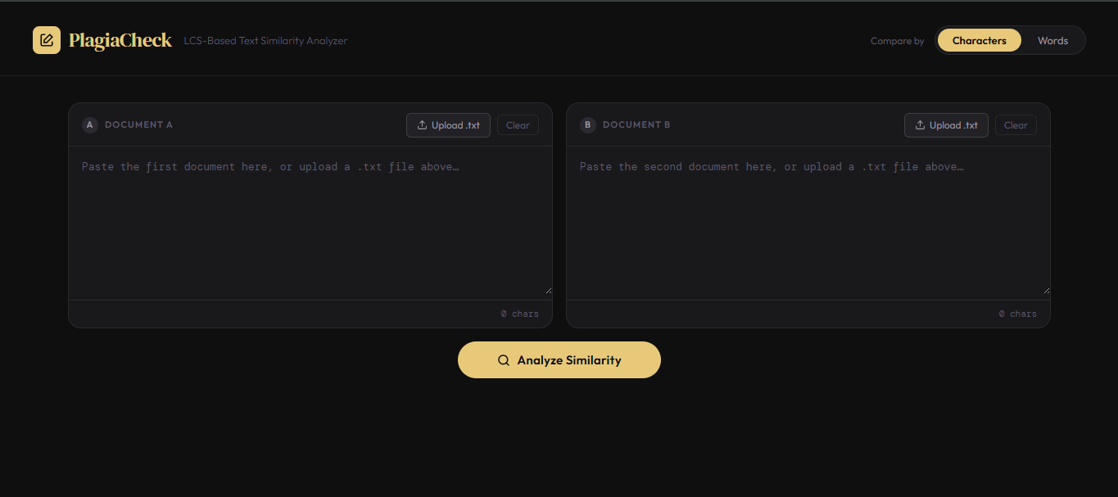

Snapshot 2 — Results: Highlighted Match View
After entering two similar texts and clicking 'Analyze Similarity', the Highlighted Match tab displays matched tokens in green (Document A) and blue (Document B).
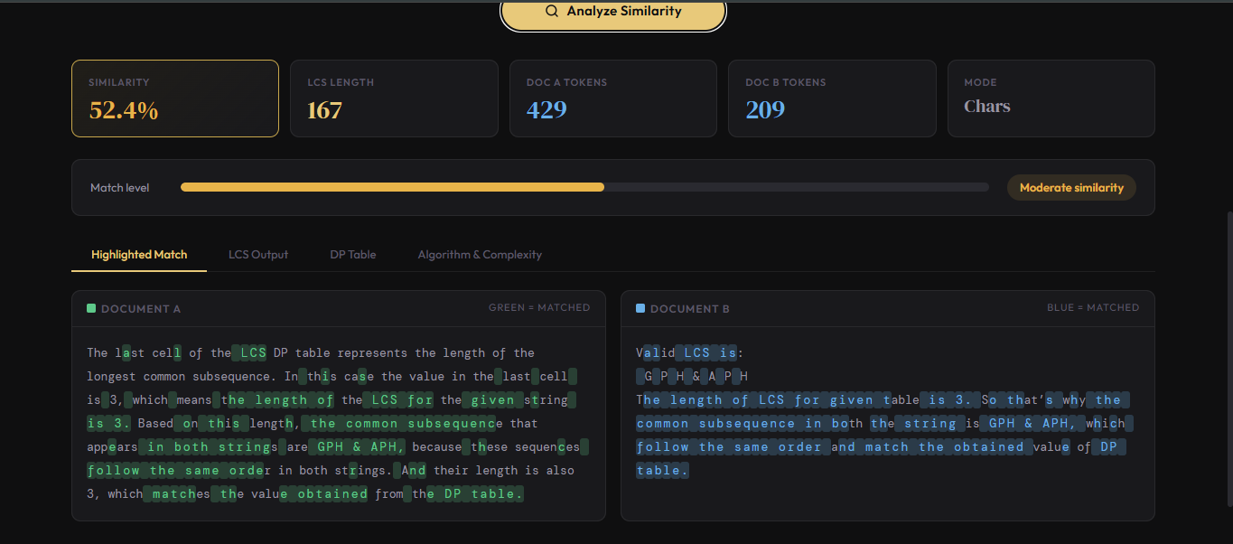

Snapshot 3 — DP Table View
The DP Table tab visualizes the dynamic programming matrix. Cells on the optimal backtrack path are highlighted in green, tracing from dp[m][n] back to dp[0][0].
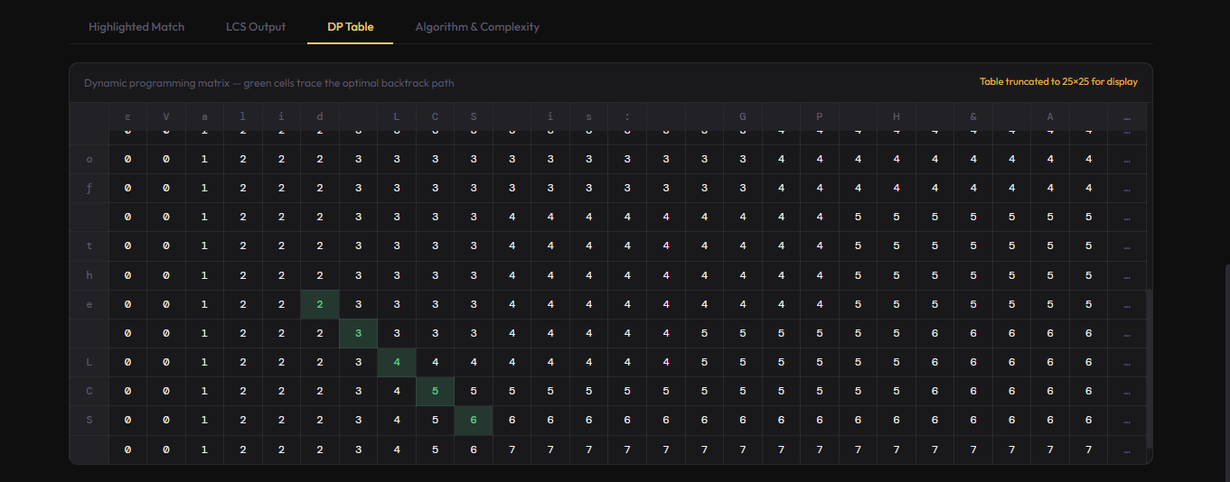

Snapshot 4 — Algorithm & Complexity Tab
The Algorithm tab shows the step-by-step explanation and real-time complexity values (m, n, cells computed, LCS length) calculated from the current input.
